The electromagnetic spectrum
  - Student worksheet
Describe wave properties and calculate wavelengths relevant to radio astronomy. Show your reasoning and include units in each answer.
Name ______________________________ Date __________________

Wave properties
Mechanical waves need a medium, such as air or water. Electromagnetic waves can travel through a vacuum. Radio waves, microwaves, infrared, visible light, ultraviolet, X-rays, and gamma rays are all electromagnetic waves.
Property | Meaning
Period T | Time for one oscillation, measured in seconds.
Frequency f | Oscillations per second, measured in hertz.
Amplitude A | Maximum size of the disturbance relative to equilibrium.
Wavelength λ | Distance between repeating points, measured in meters.
Wave speed v | Speed at which the disturbance travels.

Describe a wave
1. How are frequency and period related? Write an equation and explain its meaning.
________________________________________________________________________
________________________________________________________________________
2. Label the amplitude and wavelength on this snapshot of a wave. Mark the equilibrium level.
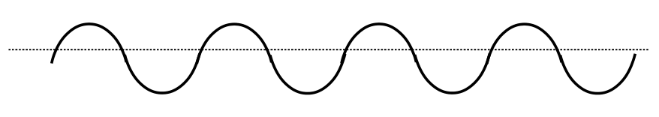
A wave shown as a function of position.

Connect speed and wavelength
Wave speed satisfies v = fλ. In a vacuum, electromagnetic waves travel at c = 3.00 × 10⁸ m/s. Therefore c = fλ. Higher frequency means shorter wavelength at the same speed.

Calculate and compare wavelengths
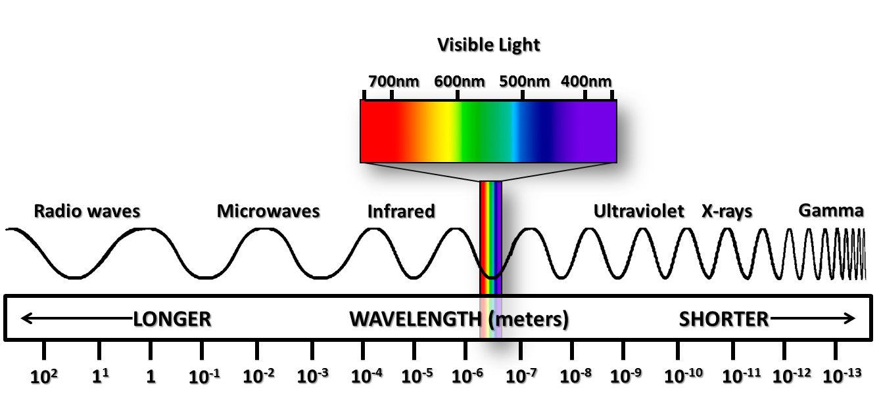
The electromagnetic spectrum spans a wide range of wavelengths.

Hydrogen emission
3. The horn telescope detects neutral hydrogen near 1420.4 MHz. Calculate the wavelength and express your answer in centimeters.
________________________________________________________________________
________________________________________________________________________
________________________________________________________________________

A radio frequency range
4. Consider signals from 87 MHz to 107 MHz. Calculate their wavelength range in meters. Which frequency has the longer wavelength?
________________________________________________________________________
________________________________________________________________________
________________________________________________________________________

An atomic scale
5. X-ray wavelengths can be comparable to atomic dimensions. Choose a reasonable atomic diameter or radius and give its value in meters. Calculate the frequency of light with that wavelength. Record your source for the atomic size.
________________________________________________________________________
________________________________________________________________________
________________________________________________________________________

