Celestial coordinate systems
  - Reference handout and exercises
Coordinate systems describe directions and positions. Astronomers choose a system that fits the observation or question.

The celestial sphere
Imagine distant objects projected onto a sphere centered on the observer. This model describes directions without representing the objects’ distances.
Earth’s rotation makes stars appear to move across the local sky. Different coordinate systems describe this motion in different ways.

1 Spherical coordinates
A spherical coordinate system uses a radius and two angles. The diagram shows one common convention for r, θ, and φ.
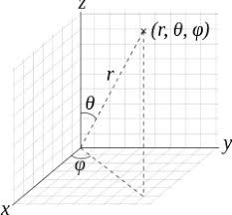
Figure 1. Radius and angles in a spherical coordinate system.

2 Longitude and latitude on Earth
Latitude measures angle north or south of the equator. Longitude measures angle east or west of the prime meridian.
The prime meridian passes through Greenwich and defines 0° longitude.
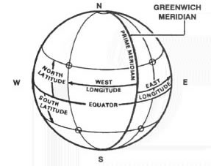
Figure 2. Terrestrial latitude and longitude.

Horizontal coordinates
Horizontal coordinates describe the sky from a particular place and time. A star’s horizontal coordinates change as Earth rotates.
Term | Meaning
Zenith | The direction straight overhead, at 90° elevation
Nadir | The direction opposite the zenith, straight down
Horizon | The reference plane perpendicular to the zenith–nadir direction
Celestial meridian | The great circle through the celestial poles, zenith, and nadir
Azimuth | Direction around the horizon, measured from north through east
Elevation | Angle above the horizon; also called altitude
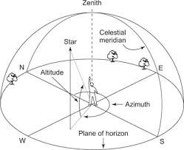
Figure 3. Azimuth and elevation locate an object in the local sky.
In this convention, north is 0°, east is 90°, south is 180°, and west is 270° azimuth.

Equatorial coordinates
Right ascension and declination provide sky coordinates that do not depend on the observer’s location.
For a short observing session, a distant star’s catalog coordinates remain effectively fixed. Its azimuth and elevation still change.
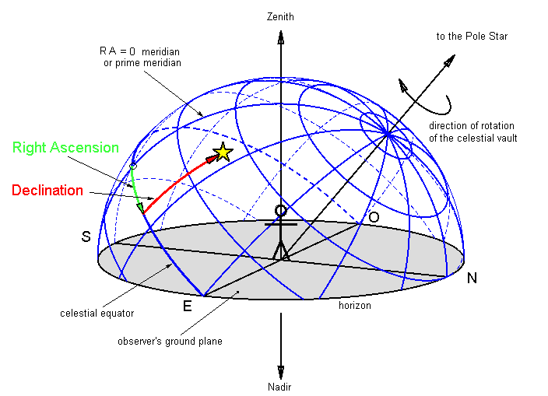
Figure 4. Right ascension and declination on the celestial sphere.

Right ascension (RA)
RA measures angle eastward along the celestial equator from the March equinox. One hour of RA equals 15°.

Declination (Dec)
Declination measures angle north or south of the celestial equator. The equator has declination 0°.
The north celestial pole has declination +90°. The south celestial pole has declination −90°.
The celestial equator projects Earth’s equator onto the sky. The celestial poles lie along Earth’s rotation axis.

Galactic coordinates and exercises
Galactic coordinates describe directions relative to the Milky Way’s plane, as viewed from our position in the Galaxy.
Coordinate | Definition
Galactic longitude | Angle around the Galactic plane, from 0° toward the Galactic center to 360°
Galactic latitude | Angle above or below the Galactic plane, from −90° to +90°
Longitude 180° points away from the Galactic center. The original diagram divides longitude into four quadrants.
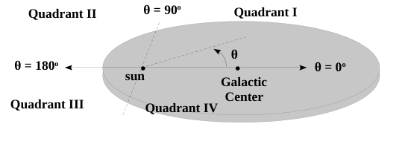
Figure 5. Galactic longitude and quadrants viewed from above the Galactic plane.

Exercises
- An observer in Charlotte looks straight up. How does that direction’s declination relate to the observer’s latitude?
- A star rises in the east at 30° elevation, then passes overhead. Does its RA change during this motion? Explain.
Use a sketch to distinguish movement across the local sky from a change in a star’s catalog coordinates.

Sources
Adapted from the DSPIRA coordinate-systems handout. Original diagrams retained.
NASA JPL: Right ascension
NASA: Using multiwavelength Milky Way maps

