Build a simple spectrometer
  - GNU Radio teaching guide
Build a flowgraph that groups receiver samples, measures their frequency content, and displays an integrated power spectrum.
The original example uses a 10 MHz Airspy configuration. Screenshots show its interface; other receivers and software versions may differ.
Current receiver settings and supported sample rates

Signal processing overview
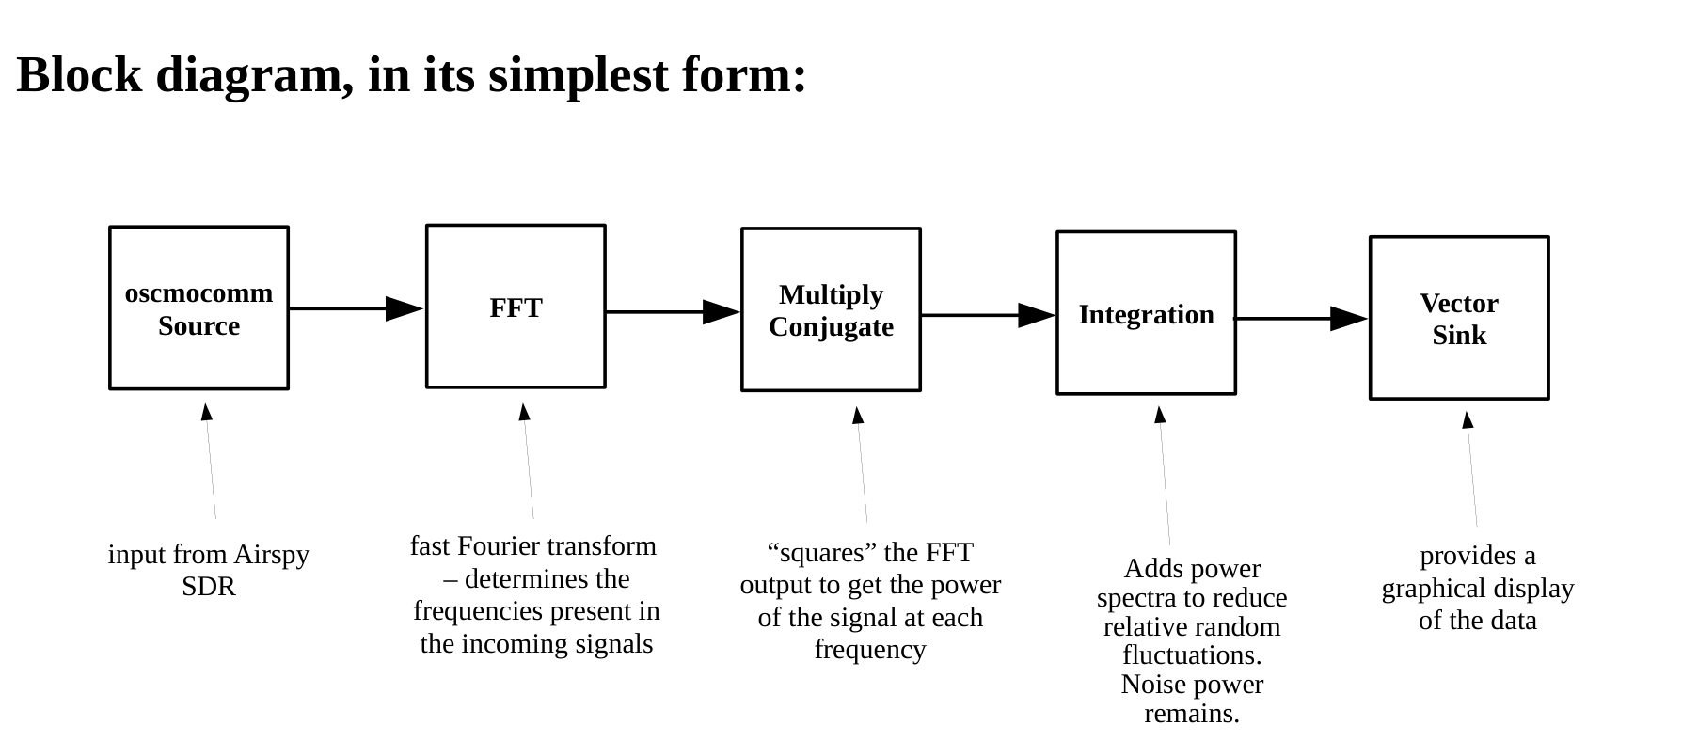
Figure 1. Original block diagram. Integration reduces relative fluctuations; it does not remove mean noise power.

The completed flowgraph
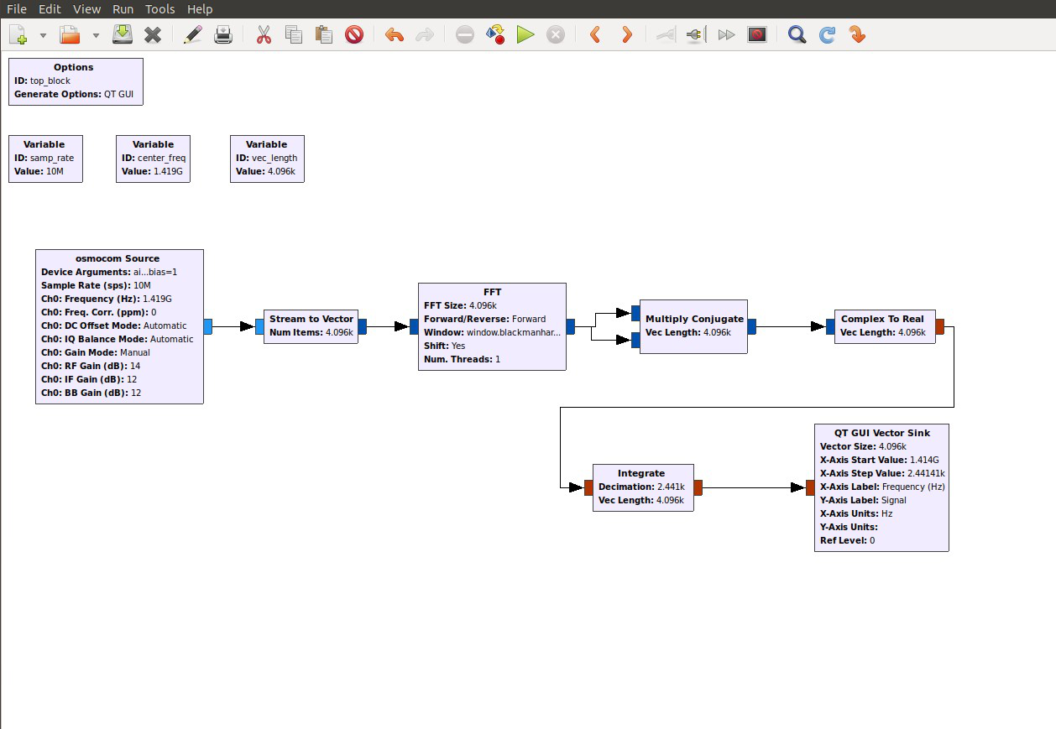
Figure 2. GNU Radio flowgraph for the original simple spectrometer.

1 Configure the receiver
Add an Osmocom Source for the Airspy receiver. Use a receiver-supported sample rate and settings appropriate to the connected amplifier.
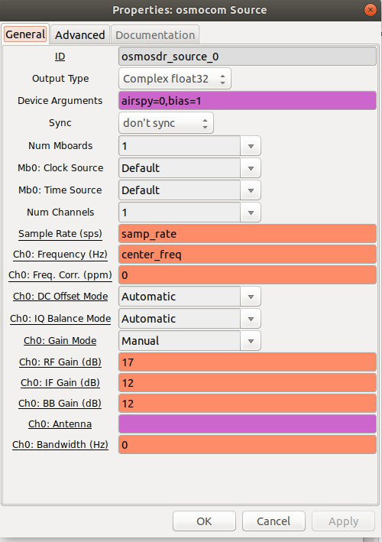
Figure 3. Osmocom Source settings in the original example.
Setting | Original example
Device arguments | airspy=0,bias=1
Sample rate | samp_rate = 10e6
Center frequency | center_freq = 1.419e9
RF gain | 17
IF gain | 12
The bias=1 option enables antenna-cable power for a compatible LNA. USB powers the Airspy itself.
Use the current receiver guide for your hardware. Leave other settings at their defaults unless the receiver requires a change.

2 Group samples into vectors
Stream to Vector groups consecutive complex samples for the FFT. Set vec_length to 4096 in a Variable block.
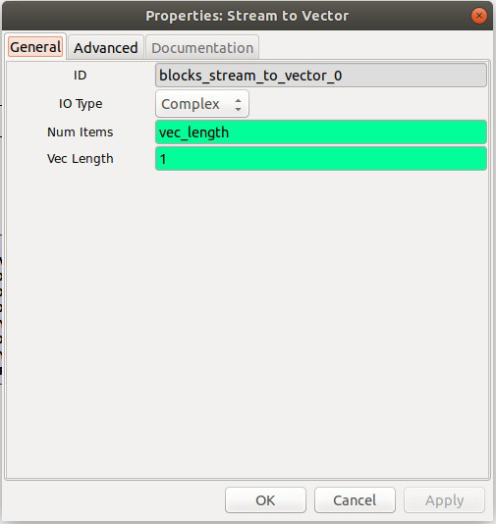
Figure 4. Stream to Vector groups 4096 scalar samples per output vector.
Setting | Value
Input type | Complex
Num items | vec_length
Vec length | 1
The input Vec length of 1 describes scalar input items. Num items sets the number grouped into each output vector.
Connect the Osmocom Source output to this block, then connect its vector output to the FFT.

3 Transform the signal into frequencies
The FFT transforms each vector into frequency channels. Use the same vector length throughout the processing chain.
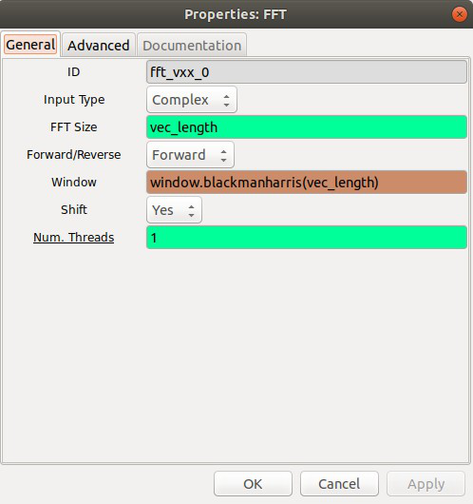
Figure 5. FFT settings for the original 4096-channel example.
Setting | Value
Input type | Complex
FFT size | vec_length
Direction | Forward
Window | window.blackmanharris(vec_length)
Shift | Yes
The window length must match the FFT size. Shift places the center frequency in the middle of the spectrum.

4 Calculate power
Connect the FFT output to both inputs of Multiply Conjugate. This computes each complex value times its own conjugate.
The result is squared magnitude, proportional to power. Complex to Real then extracts its real component.
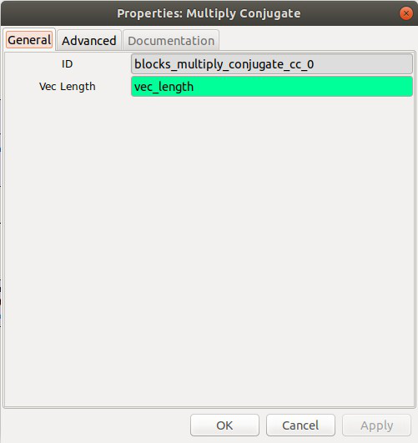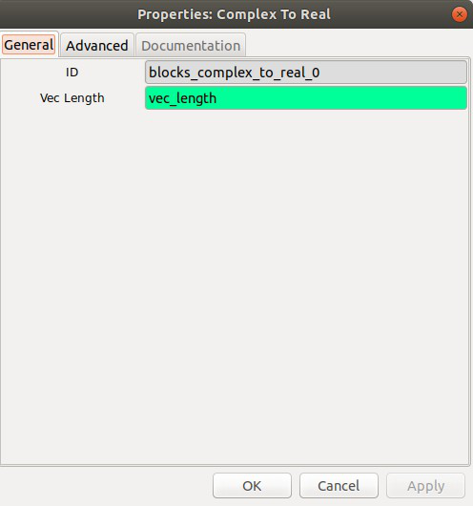
Figure 6. Multiply Conjugate (left) and Complex to Real (right).
Block | Setting
Multiply Conjugate | Vec length = vec_length
Complex to Real | Vec length = vec_length
Connect Multiply Conjugate to Complex to Real. Connect the real-valued output to Integrate.

5 Integrate successive spectra
Integrate adds corresponding channels across successive spectra. Random fluctuations decrease relative to the mean as more spectra are combined.
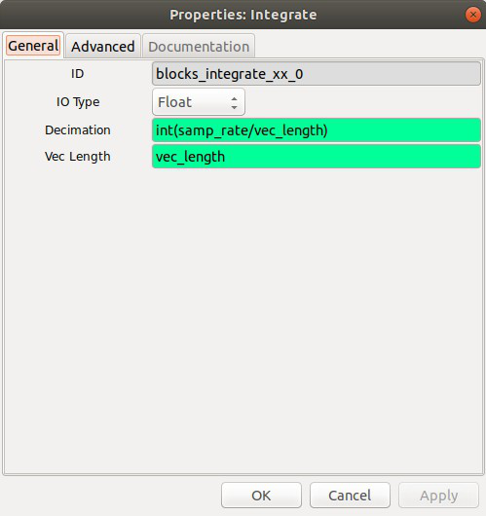
Figure 7. Integrate settings for approximately one output spectrum per second.
Setting | Value
Input type | Float
Decimation | int(samp_rate / vec_length)
Vec length | vec_length
At 10 MHz and 4096 samples per FFT, the input provides 10,000,000 / 4096 = 2441.40625 spectra per second.
Decimation 2441 sums 2441 spectra, producing about one output per second. Divide by 2441 if you need their average.
Summing increases the mean signal and noise levels. The mean noise power remains; it does not cancel.

6 Display the spectrum
Connect Integrate to a QT GUI Vector Sink. The sink plots the processed power values against frequency.
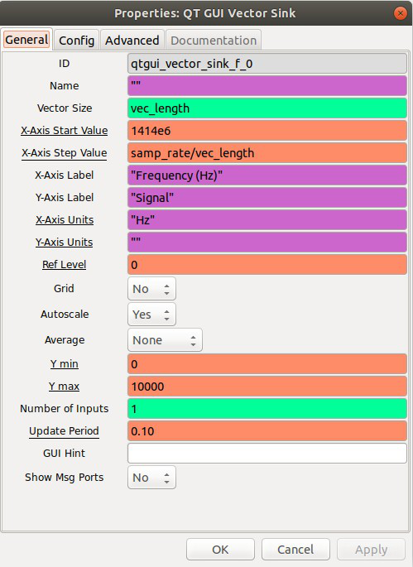
Figure 8. QT GUI Vector Sink settings in the original example.
Setting | Value
Vec size | vec_length
X-axis start | center_freq − samp_rate / 2 = 1414e6 Hz
X-axis step | samp_rate / vec_length
X-axis label | Frequency (Hz)
Autoscale | Yes
The displayed band extends from about 1414 to 1424 MHz. The 1420.4 MHz hydrogen line lies within this band.
Channel spacing is 10,000,000 / 4096, or about 2441 Hz. It is not the full effective spectral resolution.

Check the display and explain the result

Display settings
Keep frequency units in the axis label. The X-axis Units setting supplies units for the cursor readout.
With Autoscale enabled, the display adjusts its vertical range. Use the original Y minimum of 0 when setting a fixed range.
Leave other settings at their defaults. Confirm the plotted band matches the receiver’s center frequency and sample rate.

Discussion and reflection
- Why must the FFT size match the vector length?
- What happens to output rate when the integration count increases?
- How does summing spectra differ from averaging them?
- Which settings control the frequency axis?

Sources and related lessons
Adapted from the DSPIRA simple-spectrometer teaching guide. Original flowgraph diagram and screenshots retained.
Current DSPIRA software installation
GNU Radio: FFT
GNU Radio: Integrate

