Mini horn telescope construction and operation
  - Construction and observing guide
Build two mini horn telescopes, connect their receivers, and collect hydrogen spectra. Assemble the horn, can receiver, and wooden stand separately before joining them.

Construction materials for two telescopes
Quantity | Material
1 | 4 × 8-foot sheet of 1/2-inch foil-faced rigid foam insulation
By cut list | 2 × 2 lumber, with allowance for saw cuts
1 roll each | Aluminum foil tape and masking tape
24 | 3 1/2-inch bolts with wing nuts
4 | 3 1/2-inch flat-head wood screws
8 | 1-inch flat-head wood screws
2 | New, empty F-style oblong 1-gallon metal cans
2 | 4-inch pieces of 4-gauge solid copper grounding wire
2 | Four-hole, panel-mount SMA male solder terminals with RF coax adapters
1 roll | Solder
The insulation sheet can provide six horn shells. This parts list covers two complete telescopes.
Scrap foam must be at least 16 × 48 inches. Plan lumber from the cut list, including an allowance for saw cuts.
Use new, empty metal cans. Do not cut, drill, or heat a container that held flammable liquid.

Tools
Gather a drill and bits, saw, screwdriver, tape measure, box cutter, markers, metal straightedge, and smooth-edge can opener. Add a soldering iron and hot-air soldering tool.

Cut the horn panels
Use these mini-horn dimensions throughout construction. The separate 2021 horn guides describe a different design.
- Cut the 4 × 8-foot insulation sheet into two 4 × 4-foot sections. Each section supplies three horns.
- Mark the panel corners from the same left edge, using the positions below. All four panels are 14 1/2 inches high.
- Connect the matching corners as shown. Guide a sharp box cutter with a metal straightedge, then cut the four panels.
- Repeat for the second telescope.
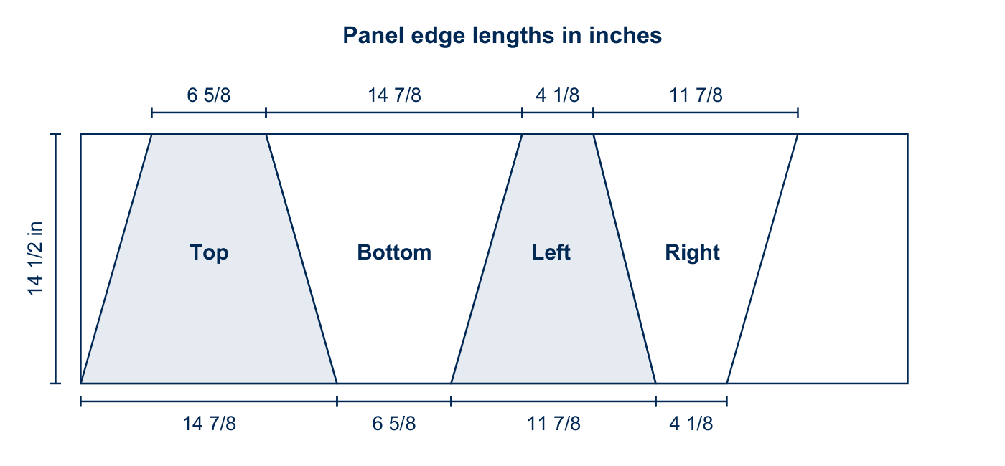
Figure 1. Panel order and edge lengths for one mini horn.

Mark positions from the left edge
Panel | Upper edge endpoints in inches | Lower edge endpoints in inches
Top | 4 1/8 to 10 3/4 | 0 to 14 7/8
Bottom | 10 3/4 to 25 5/8 | 14 7/8 to 21 1/2
Left | 25 5/8 to 29 3/4 | 21 1/2 to 33 3/8
Right | 29 3/4 to 41 5/8 | 33 3/8 to 37 1/2
The source writes 10 3/4 inches as 10 6/8 inches. Both values mark the same position.

Tape the horn panels
- Arrange the panels with foil faces upward. Alternate top, left, bottom, and right panels as shown.
- Align the short edges. Join the three adjoining seams with 2-inch foil tape.
- Fold the panels until the remaining edges meet. Match inside edge to inside edge; do not overlap the panels.
- Hold the final seam with short pieces of tape, then tape its entire inside edge.
- Tape all outside seams. Cover the top and bottom edges with foil tape.
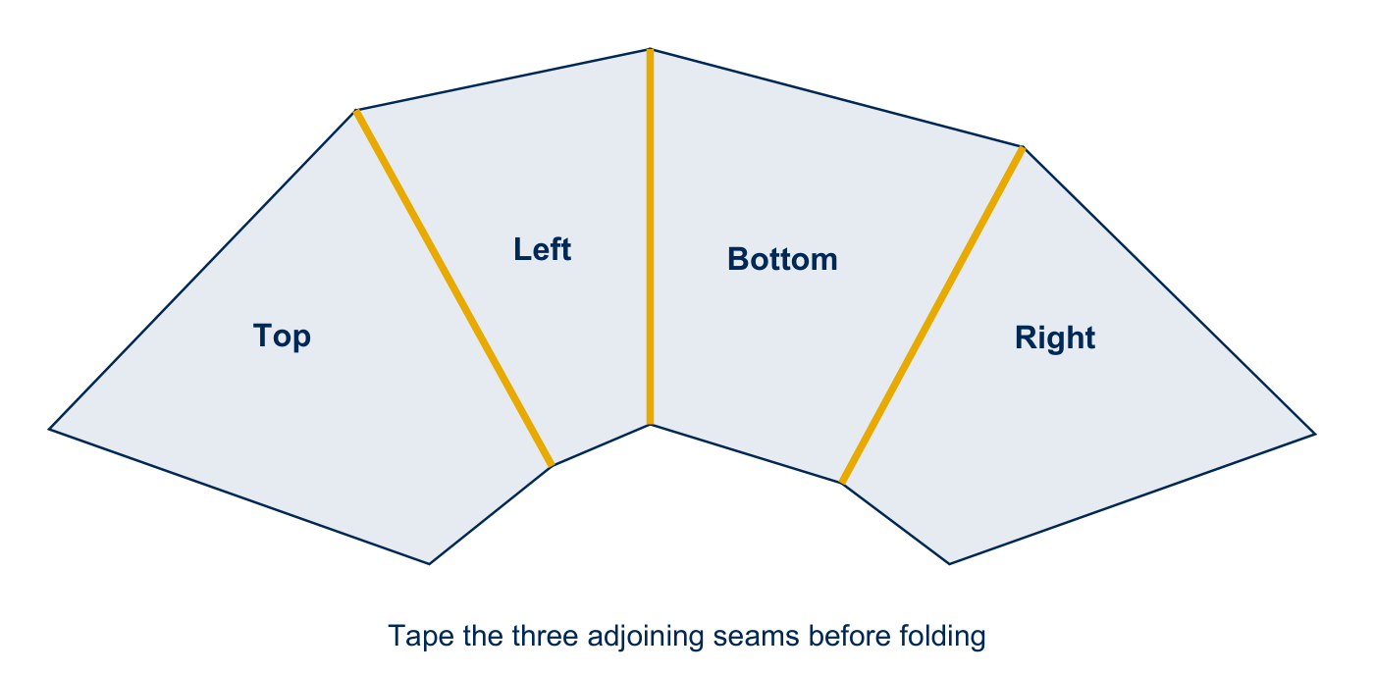
Figure 2. Arrange the four panels before folding. Gold lines mark the first three seams.
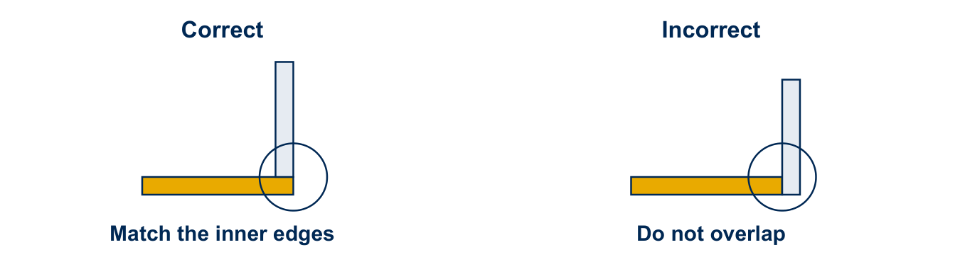
Figure 3. Align the inside edges when closing the final seam.

Prepare the can receiver
- Remove the can bottom with a smooth-edge can opener. Keep the capped end.
- Mark the wide side, centered between its edges and 5.25 cm from the capped end.
- Support the wall with a snug wood block. Drill a 1/8-inch hole, then remove the block.
- Cover the pour spout with foil tape on both the inside and outside.
- Position the drilled side upward. Heat the can and apply solder around the hole.
- Insert the antenna coupler. Keep the copper probe inside and the four-hole connector plate flat against the outside.
- Center the probe so it does not touch the metal wall. Heat the solder until it flows beneath the plate.
- Remove the heat. Let the solder solidify and the can cool before handling it.
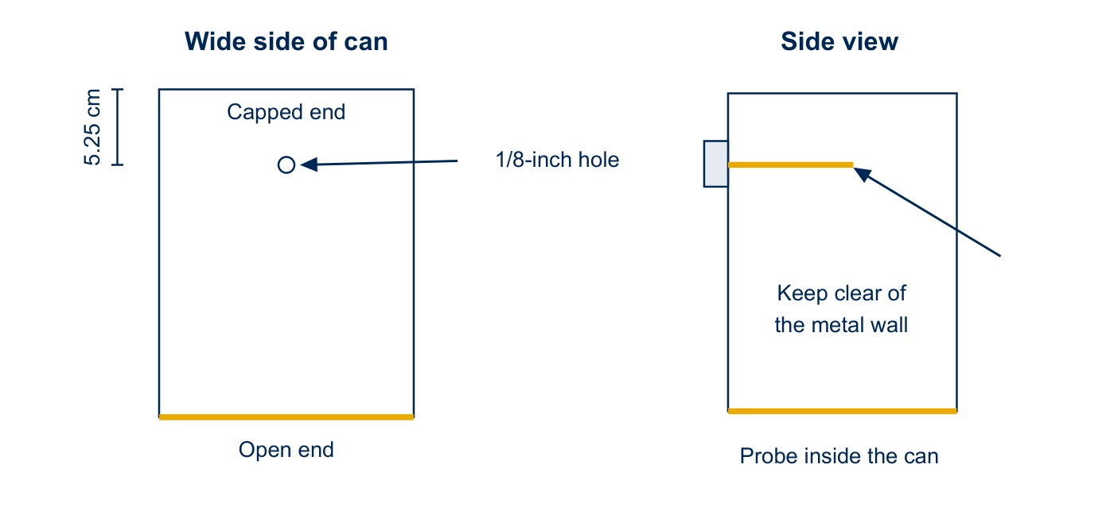
Figure 4. Place the connector on the wide side. The copper probe must remain clear of the metal wall.
The drawings show the hole location and probe clearance. They do not set the probe length.

Attach the wooden receiver frame
- Set the can on a table with the antenna connector upward. Place a 2 × 2 board beside it.
- Use the board to mark a guide line along each side of the can.
- Mark holes 1 1/2 inches and 5 inches from the open end on each side. Center them between the edge and guide line.
- Support the can with the wood block before drilling the four 1/8-inch holes. Remove the block afterward.
- Attach the two 20-inch side pieces. Trim the 8-inch crosspiece to fit between them, approximately 6 5/8 inches.
- Attach the crosspiece to form a U-shaped frame.
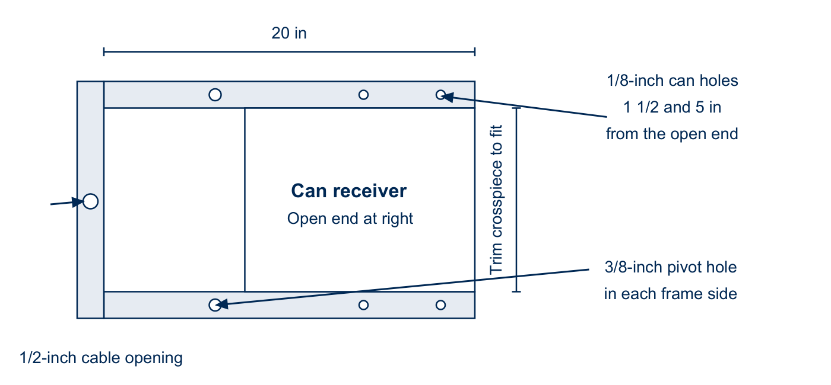
Figure 5. Receiver frame and hole locations, viewed from above.
Detail | Instruction
Cable opening | Drill a 1/2-inch hole through the crosspiece.
Stand pivots | Drill a 3/8-inch hole in each frame side, 1 1/2 inches below the can edge.
Frame joints | Use 2-inch wood screws to attach the crosspiece to the sides.
Can attachment | Use 3/4-inch wood screws from inside the can. Cover the screws with foil tape.

Cut the stand pieces
Use nominal 2 × 2 lumber. The cut list below supplies one stand, its receiver frame, and its laptop supports.
Part | Quantity | Length
Long stand legs | 2 | 34 1/2 in
Short stand legs | 2 | 30 in
Upper braces | 2 | 18 in
Lower crosspieces | 2 | 13 1/2 in
Receiver frame sides | 2 | 20 in
Receiver crosspiece blank | 1 | 8 in; trim to fit
Laptop supports | 2 | 12 in
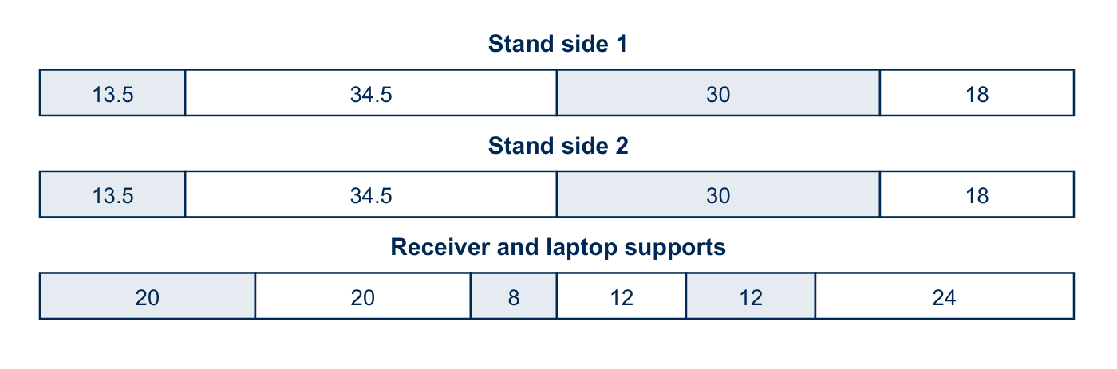
Figure 6. Original stock layout, with lengths in inches. The 24-inch section is spare stock.
The stock layout fills each 8-foot length exactly. Allow extra stock for the material removed by the saw.
For two telescopes, the listed finished pieces total 44 feet before saw cuts. Choose stock using the cut list, not that total alone.

Prepare the overlapping joints
- At the upper ends of each matching leg pair, cut a 3-inch-long section to a depth of 3/4 inch.
- Fit the two recesses together to form an overlapping joint.
- Clamp the mating pieces together. Drill a 3/8-inch hole through the center of the overlap so the holes align.
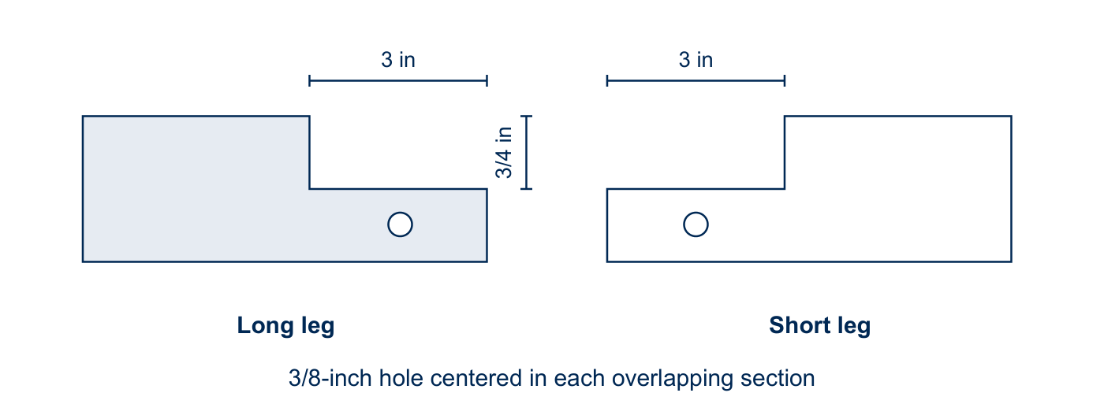
Figure 7. The half-depth recesses let the two stand legs overlap.
The 3 × 3/4-inch recess follows the original cutting-plan detail and drilling diagram.

Position the remaining holes
Use the joint positions in the next diagram. Overlap and clamp each pair before marking and drilling its 3/8-inch holes.
Location | Reference distance along the leg
Long leg to lower crosspiece | 17 in from the foot
Long leg to upper brace | 15 1/2 in from the upper joint
Short leg to upper brace | 14 in from the upper joint
Short leg to lower support | 6 in from the foot

Assemble the stand
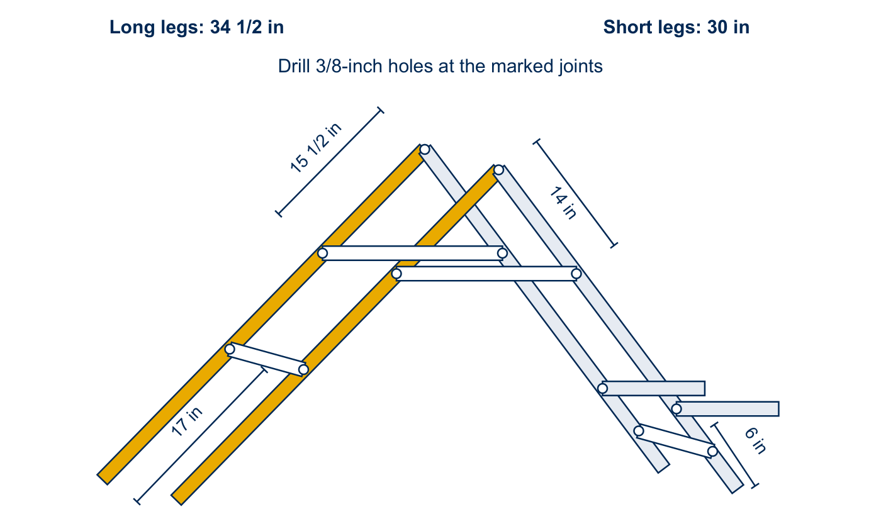
Figure 8. Joint positions and reference distances. The stand is shown schematically; use the labeled dimensions.
- Arrange the long and short legs in two matching sides. Add the braces, crosspieces, and laptop supports.
- Insert the 3 1/2-inch bolts through the aligned holes from the outside. Keep the threaded ends inward.
- Tighten a wing nut on each bolt. Check that the frame stands without twisting or moving.

Attach and mount the horn
- Insert the can through the horn mouth, capped end first. Push it toward the narrow opening until the open rim remains inside.
- If the opening is loose, align it with the can rim. Hold the joint with short pieces of foil tape.
- Tape the entire joint inside and outside. Cover the exposed can rim and keep the can from moving.
- Remove the stand pivot bolts. Place the receiver frame inside the stand and align the pivot holes.
- Reinsert the bolts with their heads inside the receiver frame and threaded ends outward. Tighten the wing nuts enough to retain smooth movement.
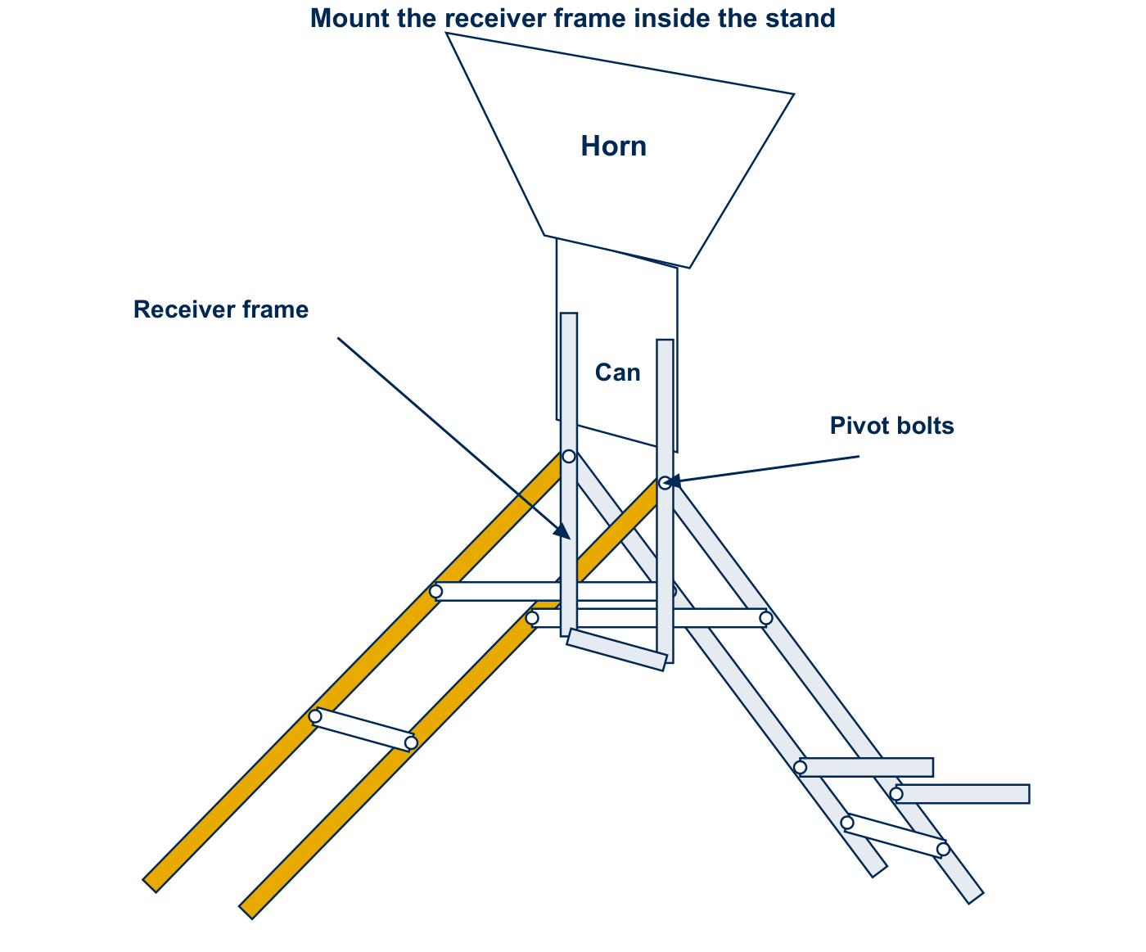
Figure 9. The receiver frame fits inside the stand and pivots on the two upper bolts.

Connect the electronics
Quantity for two telescopes | Part
2 | Airspy Mini software-defined radio receivers
2 | Male SMA to male SMA coaxial cables, at least 3 feet long
2 | DSPIRA low-noise amplifiers
2 | USB cables that fit the Airspy and computer
The low-noise amplifier is called the LNA throughout this guide.
- Attach the LNA input to the SMA connector outside the can. The input connector points perpendicular to the amplifier board.
- Connect the LNA output to the Airspy using the SMA cable. The output connector points along the amplifier board.
- Connect the Airspy to the computer with its USB cable. Check that each cable end matches its port.
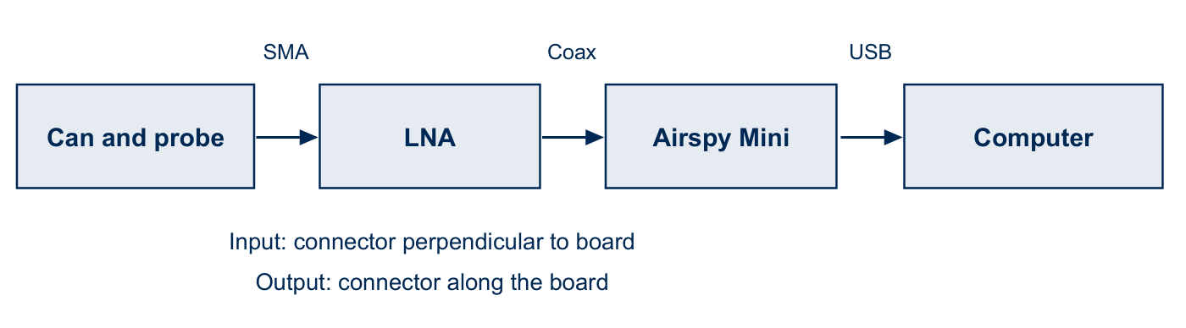
Figure 10. The signal travels from the can and probe through the LNA and Airspy to the computer.
Request kit equipment from WVU DSPIRA

Prepare the observing computer
The current application is calibrated-spectrometer.grc in the DSPIRA software repository. Older images and videos call it spectrometer_w_cal.grc.
Current software installation guide
Receiver settings for Airspy and other devices

Use a supplied bootable USB drive
- Turn off the computer. Connect the receiver and insert the supplied USB drive into a separate port.
- Start the computer and open its boot menu. F12 works on the computers used in the original guide; other models differ.
- Select the USB drive. Allow Ubuntu and the desktop to finish loading.
- Open the spectrometer flowgraph supplied with that image. Allow GNU Radio to load before running it.
- Check the receiver settings, recording folder, and clock before observing. Older images use grc_data and default to UTC.

Create a replacement USB drive
DSPIRA bootable images and instructions
- Choose an image that supports your computer. Check its drive-capacity requirements before downloading.
- Extract the downloaded ZIP file. Back up the USB drive before writing the image.
- Use balenaEtcher to write the extracted image. This erases the selected drive.
- Boot from the USB drive using its instructions. Confirm receiver operation and the recording folder before collecting data.
Screenshots in this guide show the original interface. Use the current setup guides when an installed version differs.

Recognize the hydrogen spectrum
The horn detects radio waves near the neutral hydrogen line at 1420.4 MHz. It also receives local interference and noise from its electronics.
Calibration estimates the system response so the hydrogen feature is easier to measure. It does not remove every source of interference.
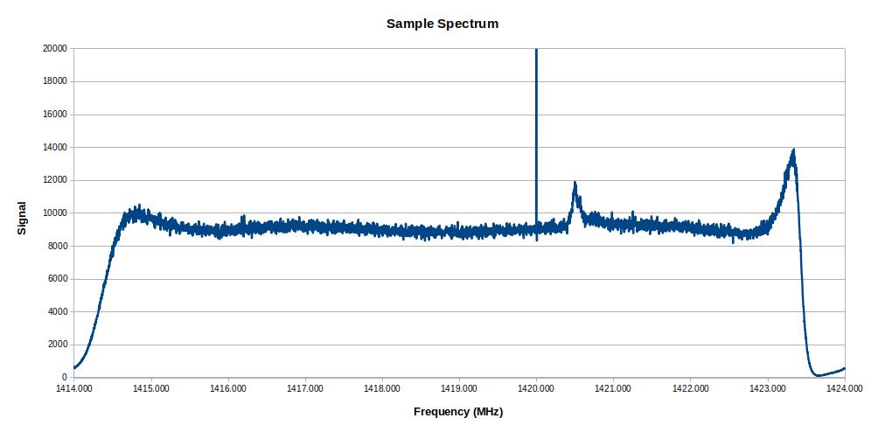
Figure 11. A hydrogen feature appears near 1420.4 MHz in this example spectrum.
The original display spans roughly 1414 to 1424 MHz. The displayed band depends on the receiver and sample-rate settings.
The broad background shape comes partly from the receiver and signal processing. Its level can change as the telescope points at different objects.
An instrumental spike may appear near 1420.0 MHz. Do not confuse that feature with the nearby hydrogen line.
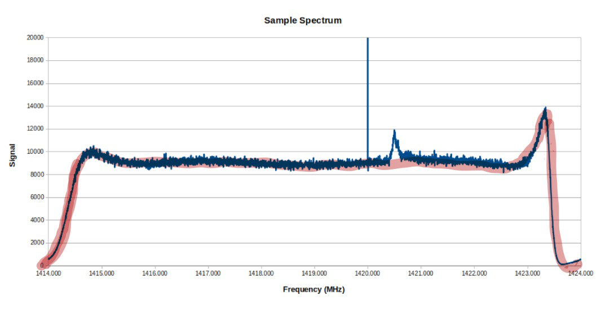
Figure 12. The system background is highlighted in the original example.

Read the Spectrum tab
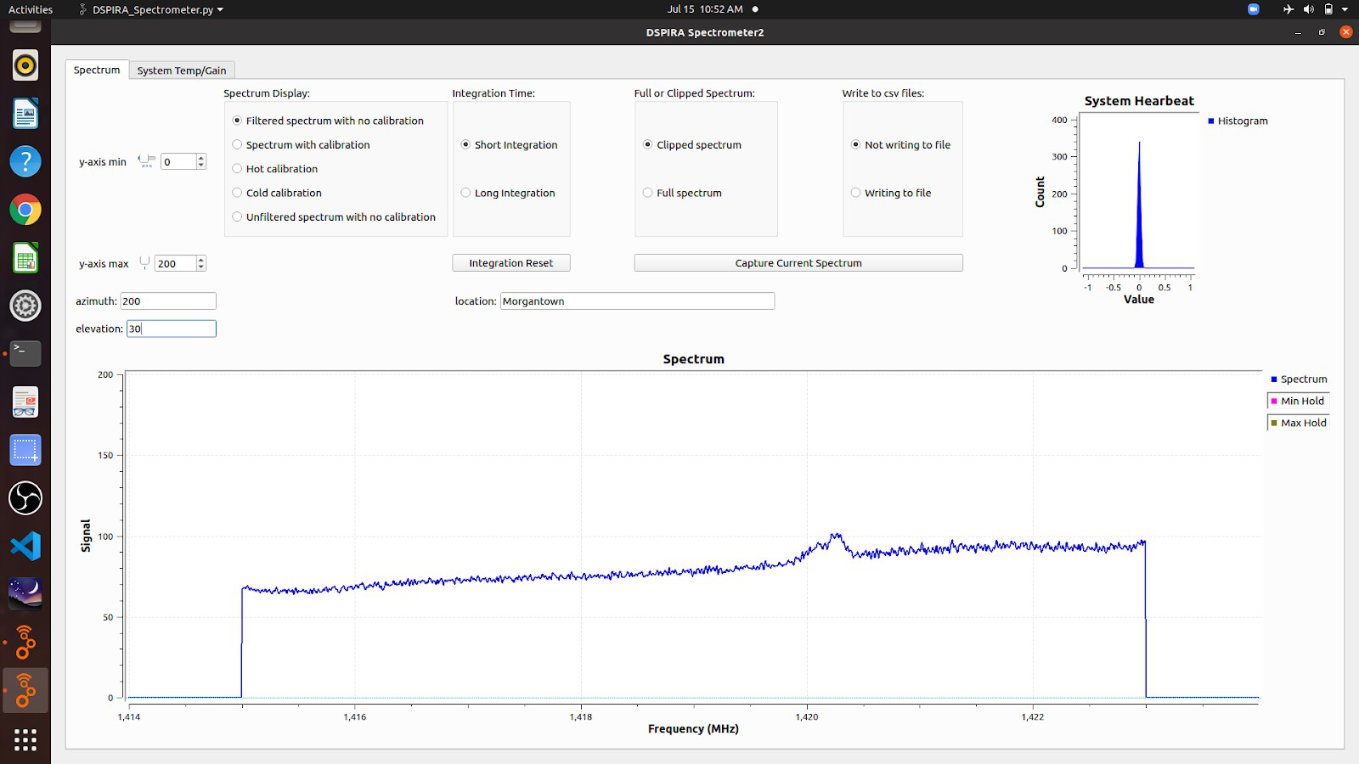
Figure 13. Spectrum display and controls in the original interface.
The main graph plots signal against frequency. The System Heartbeat histogram should keep updating while the program runs.
If the heartbeat freezes, check whether the program has stopped before restarting it.
Display choice | Use
Filtered spectrum with no calibration | View the raw spectrum with noise spikes filtered.
Spectrum with calibration | Apply the saved hot and cold references.
Hot calibration | Collect the ground reference during calibration.
Cold calibration | Collect the sky reference during calibration.
Unfiltered spectrum with no calibration | View the received spectrum without these corrections.

Choose integration and diagnostic displays
Integration averages spectra over time. Longer averages reduce random noise and help reveal weak hydrogen signals.
Control | Behavior
Short Integration | Quick checks and demonstrations; the original default is 0.4 seconds.
Long Integration | Smoother spectra at a settled pointing; the original default is 10 seconds.
Integration Reset | Restart the long average after changing the pointing.
Clipped Spectrum | Hide the distracting band edges. The original display excludes about 1414–1415 and 1423–1424 MHz.
Full Spectrum | Show the full displayed frequency band.

System Temp Gain tab
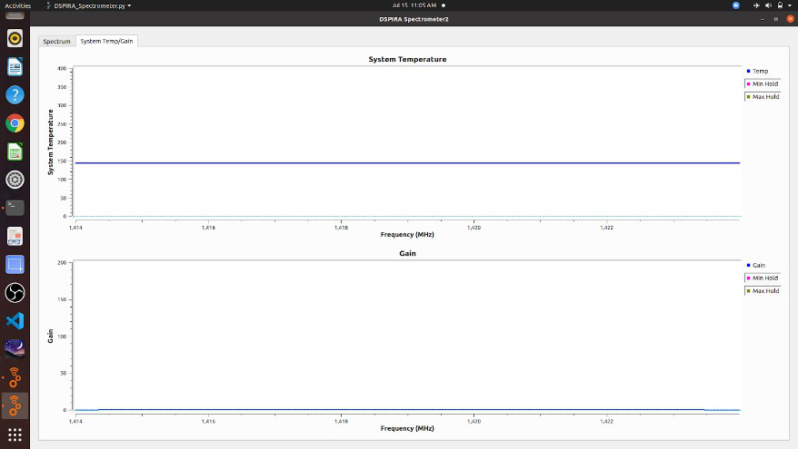
Figure 14. System temperature and gain diagnostic displays.
System Temperature estimates the noise associated with the telescope system. Gain describes the scaling applied to the measured signal.
These diagnostics help assess performance; they are not needed for every observing run.

Set the integration time and output folder
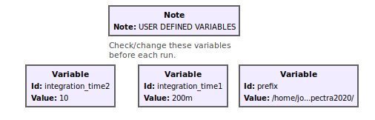
Figure 15. Variable blocks in the original GNU Radio flowgraph.
Before running, open the relevant Variable block by double-clicking it. Change its Value field and save the flowgraph.
- integration_time1 sets the short integration. integration_time2 sets the long integration. Use 0.4 seconds or longer for this flowgraph.
- prefix specifies the output folder. Confirm that it points to a writable location.
- Prevent the computer from sleeping during a long observation. Check its power settings, especially when running on battery.

Choose a recording folder
- Open the file manager and create or select the folder for your observation.
- Copy its full path. In older Ubuntu versions, the folder Properties dialog lists the parent path.
- If you copied only the parent path, append the folder name. Separate directory names with forward slashes.
- Enter the full path as a quoted string in prefix. End it with a slash.
- Save a test spectrum and confirm that the file appears in the intended folder.
Example for a folder under the user Jansky:
"/home/Jansky/radio_astronomy/horn_data_2020/"
Replace the example with an actual folder on your computer.

Start a run and save spectra
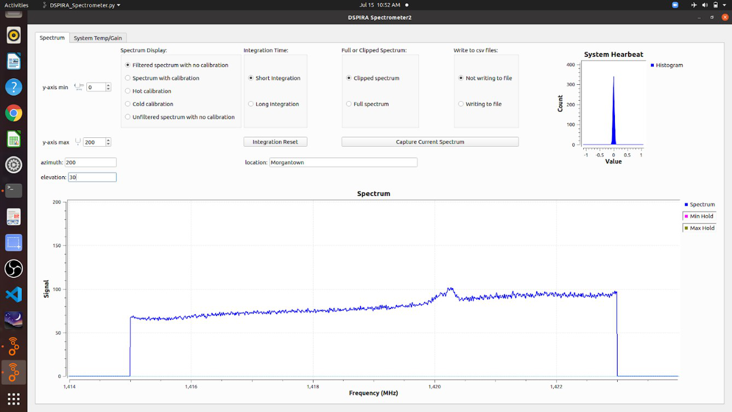
Figure 16. A typical observing display.
- Adjust ymin and ymax to fit the spectrum on screen.
- Enter the azimuth, elevation, and location. Press Enter after each entry so the program records it.
- Use Short Integration while choosing a pointing. Switch to Long Integration when the telescope is settled.
- Use Clipped Spectrum for routine viewing, or Full Spectrum when inspecting the band edges.

Save one spectrum or record continuously
Capture Current Spectrum saves the displayed spectrum as a CSV file. The prefix setting determines the destination folder.
Write to csv File saves a new file after each integration. A 10-second integration produces 60 files during a 10-minute run.
Continuous recording is useful for drift scans. Confirm the output folder and available disk space before leaving a run unattended.

Read saved data and calibrate the telescope

Saved spectra
CSV files open in spreadsheet software. They contain frequency in MHz and signal in two columns. Plot signal against frequency.
The filename includes the date, time, location, azimuth, and elevation, followed by _spectrum.
For example, 2020-07-15_11.06.14.0_Morgantown_200_30_spectrum records a July 15, 2020 observation at 11:06:14. The pointing is 200° azimuth and 30° elevation.

Collect hot and cold references
Allow about 20 minutes for warm-up. Repeat calibration when conditions or the baseline change.
- Point toward the ground. Select Hot Calibration, then Long Integration.
- Adjust ymax if needed and wait for the spectrum to settle.
- Switch to Cold Calibration before moving the telescope. This preserves the hot reference. Then select Short Integration.
- Point at open sky. Find a patch without a hydrogen peak near 1420.4 MHz, then select Long Integration.
- Wait for the display to settle. Switch to Spectrum with Calibration before moving the telescope to preserve the cold reference.
- Inspect the baseline and hydrogen feature before collecting observations.
Hot Calibration and Cold Calibration continuously replace their respective references while selected. Spectrum with Calibration uses the saved references.
Current calibration procedure and demonstration

Check the calibrated baseline
Calibrated signal is expressed in kelvin (K). The model assumes a 10 K cold reference; it is not a universal sky temperature.
A drifting or negative baseline calls for checking the setup and repeating calibration. Changing the display scale does not correct calibration.
A constant offset does not shift peak positions. Frequency-dependent drift or interference can change the spectrum shape. Check stability before quantitative analysis.

Sources and related lessons
Construction text and illustrations were adapted from the DSPIRA mini horn construction guide. Operating instructions were adapted from Dr. John Makous, DSPIRA participant and physics teacher.
Construction diagrams follow the source measurements. Interface screenshots retain the original software view. Use the current setup guides when your interface differs.
Software checks confirm the reference-saving sequence. The full calibration procedure still needs a recorded hardware check.

Continue on the DSPIRA site
Build a horn telescope
Install the current software
Spectrometer controls and demonstrations
Calibrate the horn telescope
Editable teaching resources

Contact
rail@wvu.edu

